Appendix

The Sequencing of Local Language & National Language Translations:

Why vernacular Scriptures are not being used

DATASETS
First trip, Bible photos:
https://drive.google.com/drive/folders/1ib5LQM7Mcq0vu7fskLtvQdUDFgsQCEcx
Second trip, Bible photos:
https://drive.google.com/drive/folders/0AFaWletw3m3hUk9PVA
First trip, Audio recordings of worship services:
https://drive.google.com/drive/folders/1nH6VTRuGHpM6DPS8ZRTbkma_8eF_U6jC
Second trip, Audio recordings of worship services:
https://drive.google.com/drive/folders/1p7LYyfdgYFL5Cf2D-MSETrmHCFNr3b71
Interview spreadsheet:
https://docs.google.com/spreadsheets/d/1L8E60eq7T29ez-XDAOrIjv5Q-cxc6avTaKap1Z0jUE8/edit?gid=0#gid=0

EXAMPLE PHOTOS OF CHURCHES SURVEYED

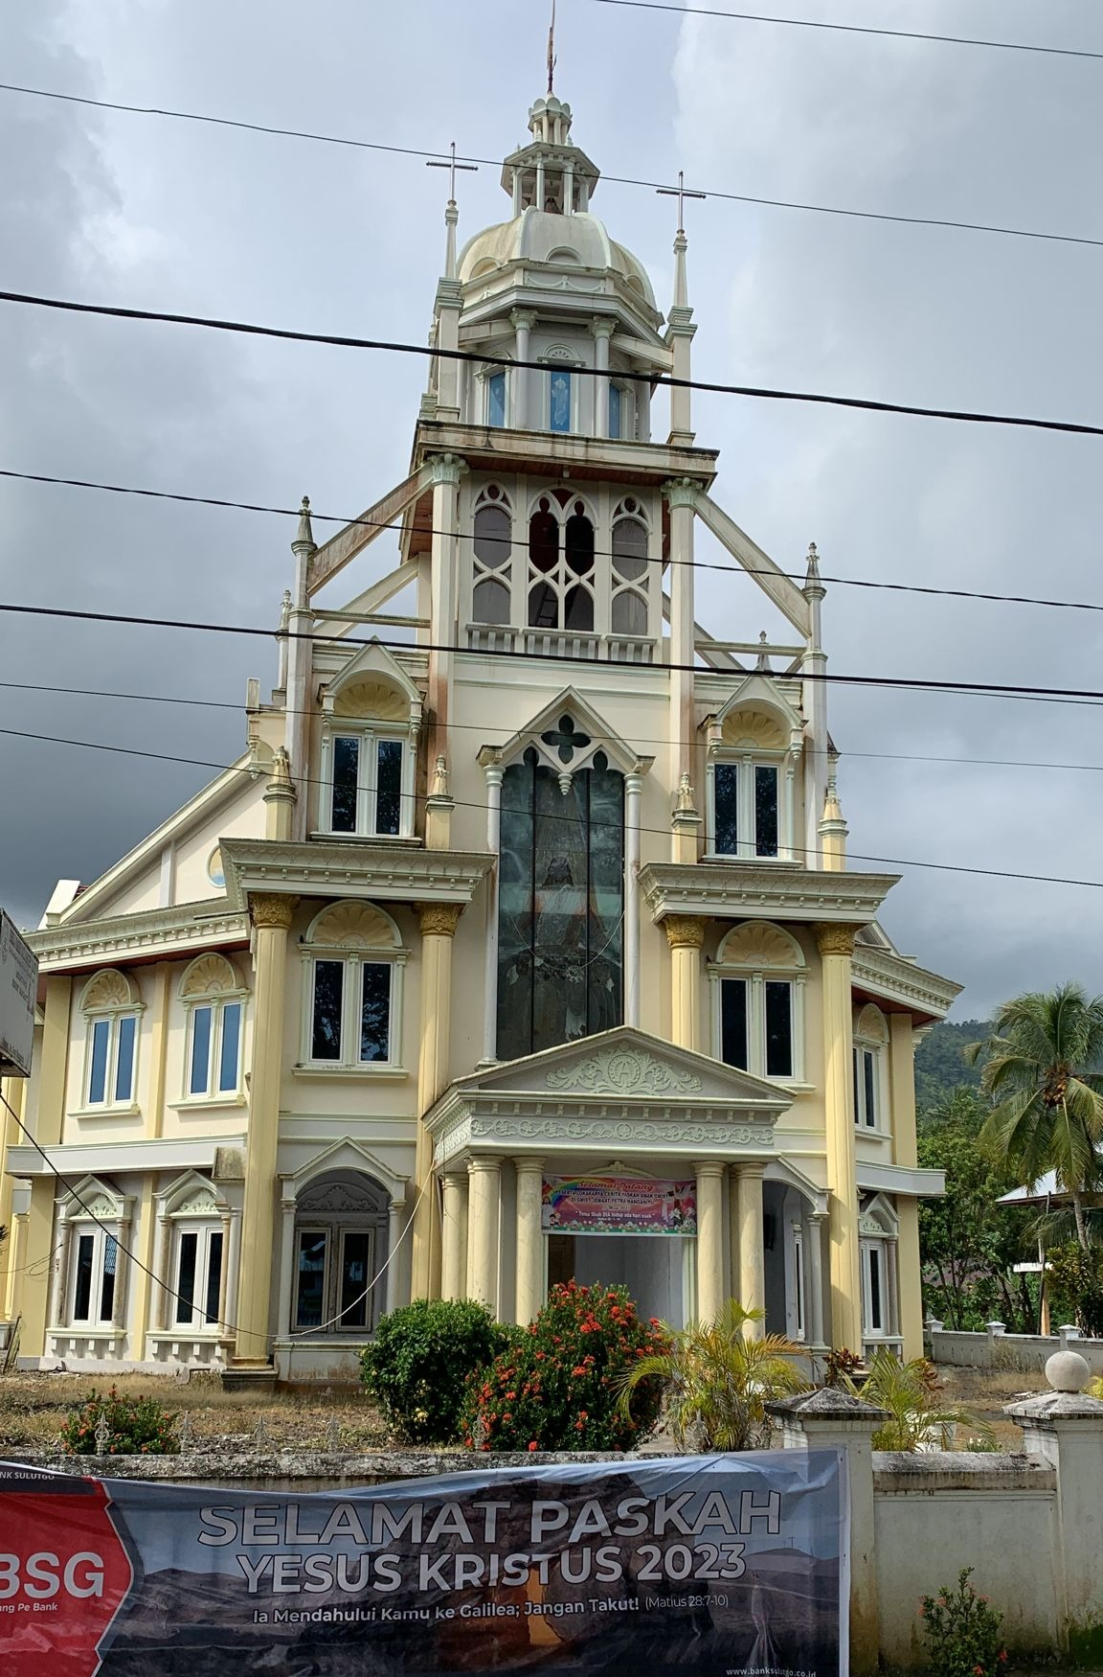
Figure 1. A Sangir church
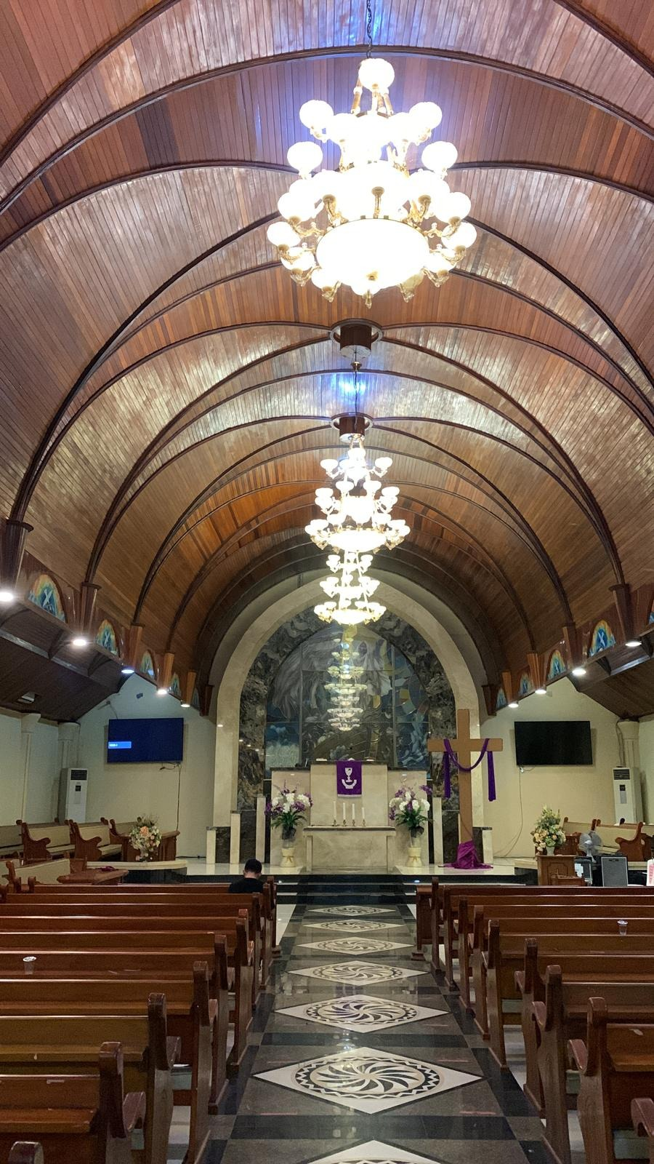
Figure 2. A church in Manado
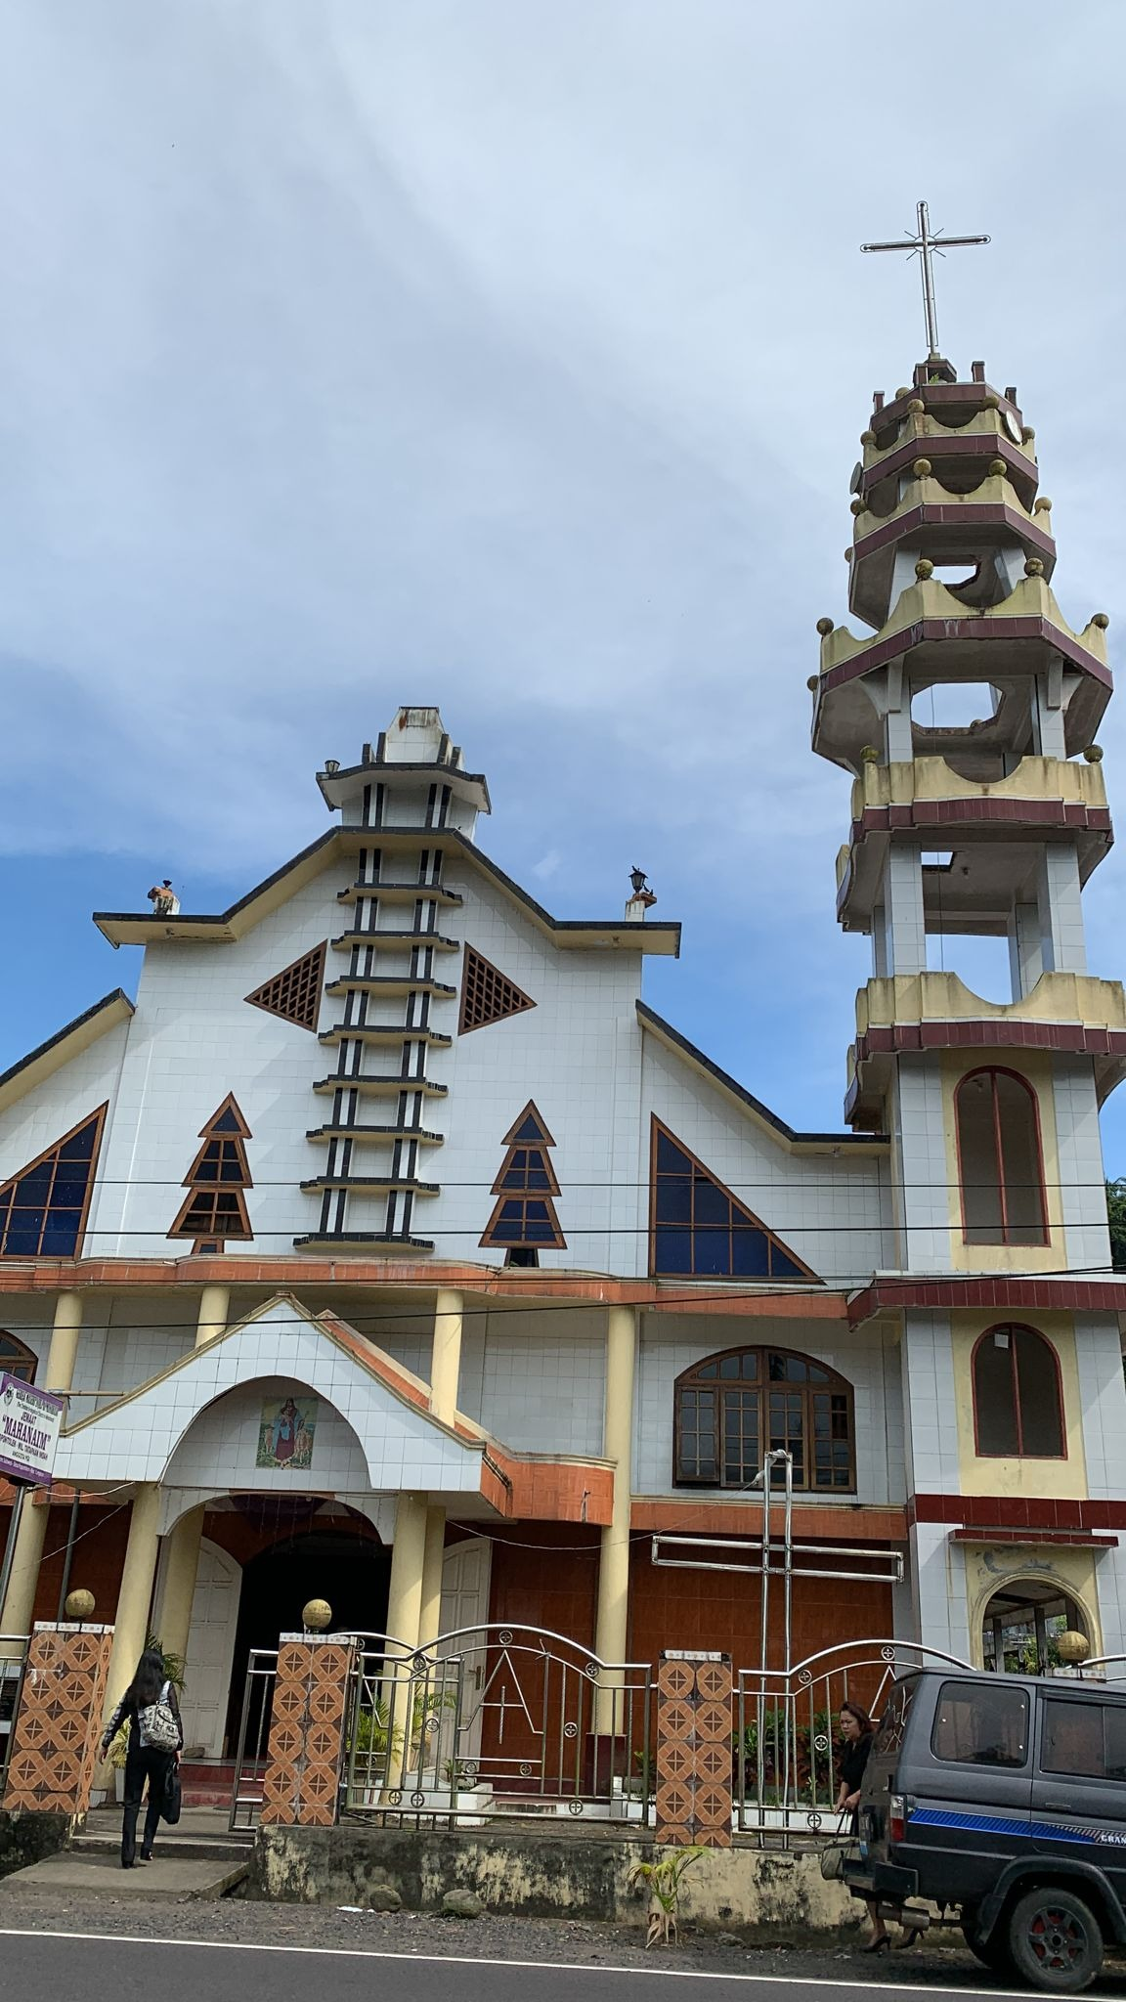
Figure 3. A Tontemboan church
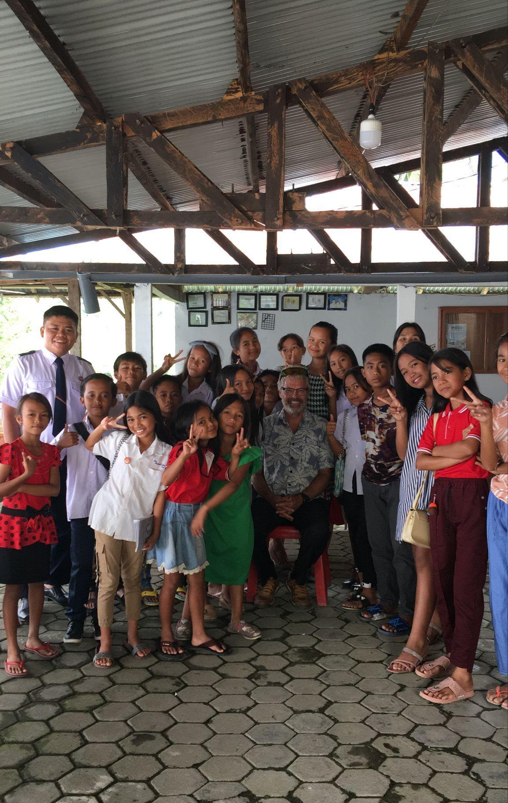
Figure 4. Uma youth group

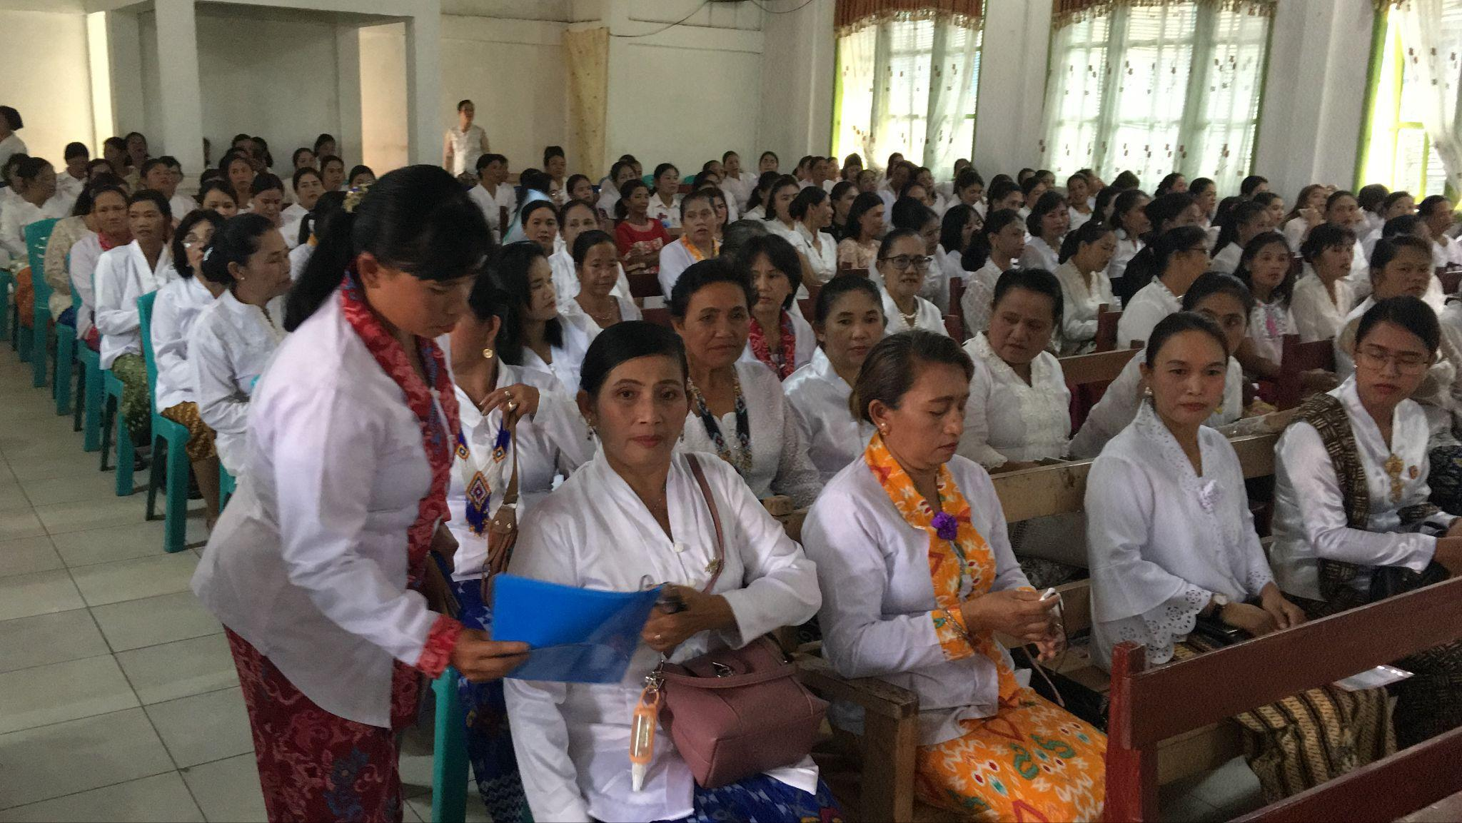
Figure 5. Bada women’s meeting

EXAMPLE PHOTOS OF BIBLES
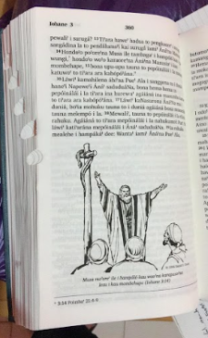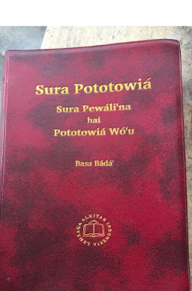
Figure 6. Example of unused Bible
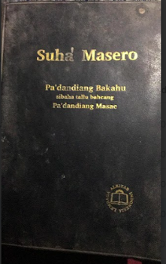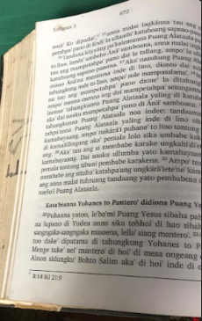
Figure 7. Example of lightly used Bible
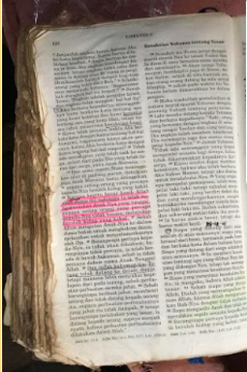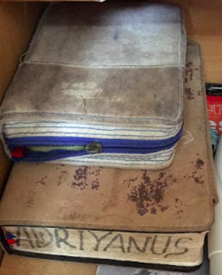
Figure 8. Example of well-used Bible

Three examples of the condition of Bibles photographed at random.
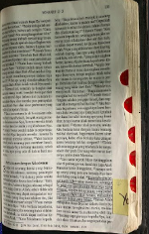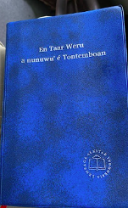
Figure 9. Comparison of ML (Indonesian, left) and LL (right) Bibles in the Tontemboan community
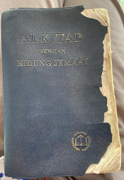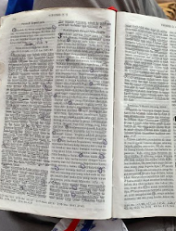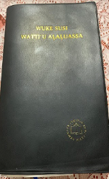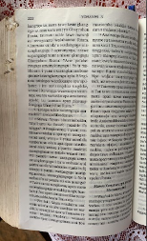
Figure 10. Comparison of ML (Indonesian, left) and LL (right) Bibles in the Talaud community
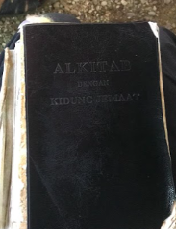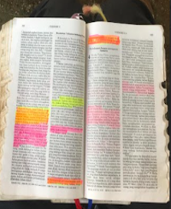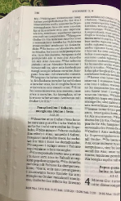
Figure 11. Comparison of ML (Indonesian, left) and LL (right) Bibles in the Mori community
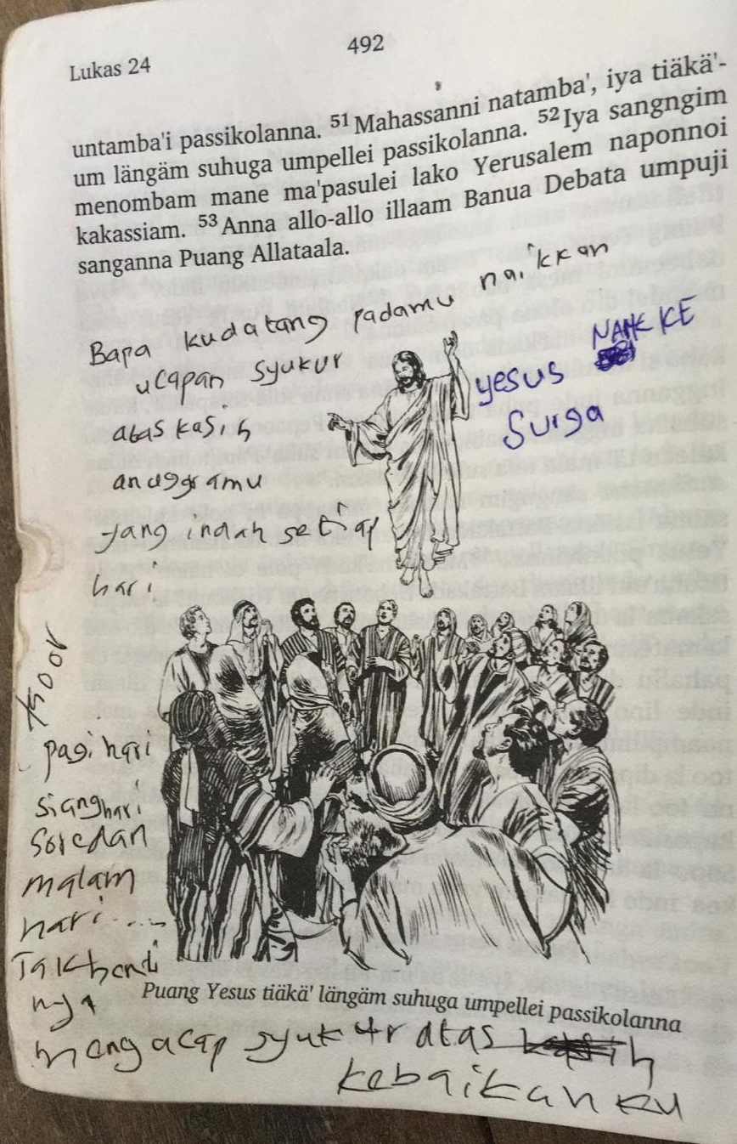
Left is an example from Bambam. The Scripture is in the LL, but the user has written notes in the NL to explain and clarify the meaning of the LL text.
Figure 12. Bambam NT with Indonesian notes

INTERVIEW QUESTIONNAIRE

Scripture Use evaluation
- For your own community, describe how often Christians read or listen to their local language Bible or Bible stories.
- For the neighboring communities, describe how often Christians read or listen to their local language Bible or Bible stories.

- Where is the local language Bible used in your community [in worship services, individual devotional use, small group Bible studies]? How often are these done in your church community? In other church communities?

- To the best of your ability, indicate which of the following statements is most true for the entire language group today.
  - The local language Bible is not used or is used only a little - we use the national language Bible in church instead.
  - The local language Bible is used occasionally by some churches and individuals.
  - The local language Bible is used regularly by some churches and individuals.
  - The local language Bible is used widely and regularly by many churches and individuals.
  - The local language Bible is used widely and regularly by most churches and individuals.
  - We use both our local language Bible and the national language Bible regularly in church
- When was scripture in your local language first used in worship settings on a regular basis in this church community? (ToT #5)

- When was scripture in the national language first used in worship settings on a regular basis in this church community? (ToT #4)

Translation Category Evaluation
- How well are you able to understand the Bible in your local language when you hear it read?
  - I don’t understand it at all.
  - I understand some of what I hear read but not most.
  - I understand most of what I hear read but not everything.
  - I understand well everything I hear read.
If they reply a, b, or c, ask them the following. Listen particularly for issues related to dialect or register, accuracy, and quality.
- What keeps you from understanding everything you read or hear?
- Which sentence describes how well you understand your local language Bible when you read it yourself.
  - I am not able to read.
  - I can read but I am not able to read my local language Bible.
  - I can read my local language Bible but I don’t understand it at all.
  - I can read my local language Bible and I understand some of what I read but not most.
  - I can read my local language Bible and I understand most of what I read but not everything.
  - I understand well everything I read.
If they answer that b. they are not able to read the local language Bible ask them the following. Listen for issues related to orthography or naturalness problems.
- Tell me why you are not able to read the Bible in your local language.
If in question 3 they reply with answers c, d, or e ask them the following. Listen particularly for issues related to dialect or register, accuracy, naturalness, and quality.
- What about the translation keeps you from understanding well everything you read?
- Listen to the following passages from the Bible and explain in your own words what the passage says. (We need audio clips from the local language scriptures if they exist. If audio versions don’t exist, it might be possible to have someone read the passages if they are good readers. Matthew 20:29-34, Acts 13:6-12 was used in the SURAM study). The surveyor should note how well each person is able to retell the passage.
- If you know the people who produced the translation in your local language, how would you describe their character?
- Obtain the following Key Terms in the vernacular – King, Kingdom, Priest, Prophet, Salvation, Messiah. Have someone read those key terms and ask the hearer(s) to explain the meaning of each.

Scripture Engagement Category Evaluation
- Describe the level of local language literacy in this group among young people, women, and men.
- When do you read any materials (including the Bible) in the L1?
- If people in this group had a choice between hearing a Bible passage read out loud or reading it themselves, which would they prefer and why?
- If people wanted to listen to the Bible or watch a Bible video, what devices are available to them for doing that? Are these devices common in your group?
- In what forms is the Bible available in your language (for example, written, audio, video, etc.)?
- How would you obtain a copy of the Bible in each of the forms you listed in the previous question?
- Are there obstacles to people in your group being able to own a copy of the Bible? If so please describe what the obstacles are.

Spiritual Category Evaluation
- How are churches in your language group?
- If someone in your community wanted to become a follower of Jesus, what would be the reaction of his family, friends, and neighbors?
- How would you describe the level of your family, friends, and neighbors’ desire to follow God?
- How do the members of your community view followers of Jesus?
- If someone wanted to become a follower of Jesus, how difficult would it be for him or her to find a person to help them?

Multilingualism Category Evaluation

- If you attend church, describe what languages are used in church services for (ToT #3):
  - Announcements
  - Greetings
  - Prayer
  - Singing
  - Preaching
  - Bible reading
  - Youth services
- Why do you think that this language (or these languages) are used for the different parts of the church service?
- In your opinion, what language(s) is most appropriate for reading and hearing scripture in church services?
- Were the languages used in today’s worship service the norm for your church community? in other words, was it a typical service?
- Which language(s) would be best for talking about spiritual matters with your friends and neighbors?
- Which language(s) would be best for learning how to follow Jesus better?
- How well do the people who lead church services know your local language(ToT #7)?
- Does your church have an official policy about which language to use? How frequently do you have services in the L1?

Partnership Category Evaluation

- Who were the main outside people and organizations involved in translating the Scriptures into your language?
- Initially who asked for a translation to be done in your language?
- What local people or groups participated in making decisions about the translation project?
- What local people or groups helped produce the translation?
- Which, if any, groups were not involved in the translation project?
- Why do you think that those groups were not involved?

